close all

clear

clc

%define parameters

C_m = 1e-9;

R_m = 10e6;

tau_m=C_m*R_m;

E_L = -70e-3;

Vth = -54e-3;

Vreset = -80e-3;

Erev_12 = -70e-3;

Erev_21 = -70e-3;

G_12 = 1e-6;

G_21 = 1e-6;

tau_syn = 10e-3;

I_0 = 2e-9;

p_R = 1;

D1(1) = 1;

D2(1) = 1;

s1(1) = 0;

s2(1) = 0.;

tau_D=0.2;

dt=1e-3; %I consider the time interval of 1 ms

t=0:dt:6-dt;

I_app1 = I_0*ones(size(t));

I_app2 = I_0*ones(size(t));

V1 = zeros(size(t));

V1(1) = E_L;

V2(1) = E_L;

%% A2

sigma_I=0;

for n = 2:length(t)

if n<=0.1/dt+1;

I_app1(n-1) = I_app1(n-1) + 3e-9;

end

if 30*0.1/dt<=n && n<=0.1/dt+30*0.1/dt-1;

I_app2(n-1) =I_app2(n-1) + 3e-9;

end

V1(n)= V1(n-1) + ((E_L - V1(n-1))/tau_m +G_21*s2(n-1)*(Erev_21-V1(n-1))/C_m + I_app1(n-1)/C_m +randn*sigma_I/C_m)*dt;

s1(n) = s1(n-1) - dt*s1(n-1)/tau_syn;

D1(n) = D1(n-1)+dt*(1-D1(n-1))/tau_D;

V2(n)= V2(n-1) + ((E_L - V2(n-1))/tau_m +G_12*s1(n-1)*(Erev_12-V2(n-1))/C_m + I_app2(n-1)/C_m +randn*sigma_I/C_m)*dt;

s2(n) = s2(n-1) - dt*s2(n-1)/tau_syn;

D2(n) = D2(n-1)+dt*(1-D2(n-1))/tau_D;

if V1(n) > Vth

V1(n) = Vreset;

s1(n) = s1(n) + p_R*D1(n)*(1-s1(n));

D1(n)=D1(n)*(1-p_R);

end

if V2(n) > Vth

V2(n) = Vreset;

s2(n) = s2(n) + p_R*D2(n)*(1-s2(n));

D2(n)=D2(n)*(1-p_R);

end

end

% Plot results

f1=figure(1);

subplot(3,1,1);

plot(t*1e3, V1, 'b', t*1e3, V2, 'r');

xlabel('Time (ms)');

ylabel('Membrane potential (mV)');

legend('Neuron 1', 'Neuron 2');

title('Membrane potential of the two neurons');

subplot(3,1,2);

plot(t*1e3, s1, 'b', t*1e3, s2, 'r');

xlabel('Time (ms)');

ylabel('Synaptic gating variable');

legend('s1','s2');

title('Gating variables of the two neurons');

subplot(3,1,3);

plot(t*1e3, I_app1*1e9, 'b', t*1e3, I_app2*1e9, 'r');

xlabel('Time (ms)');

ylabel('I-app (nA)');

legend('I-app1','I-app2');

title('applied current of the two neurons');

saveas(f1, sprintf('A2.png'));

%% A3

I_app1 = I_0*ones(size(t));

I_app2 = I_0*ones(size(t));

V1 = zeros(size(t));

V1(1) = E_L;

V2(1) = E_L;

sigma_I=50e-12;

for n = 2:length(t)

V1(n)= V1(n-1) + ((E_L - V1(n-1))/tau_m +G_21*s2(n-1)*(Erev_21-V1(n-1))/C_m + I_app1(n-1)/C_m +randn*sigma_I/C_m)*dt;

s1(n) = s1(n-1) - dt*s1(n-1)/tau_syn;

D1(n) = D1(n-1)+dt*(1-D1(n-1))/tau_D;

V2(n)= V2(n-1) + ((E_L - V2(n-1))/tau_m +G_12*s1(n-1)*(Erev_12-V2(n-1))/C_m + I_app2(n-1)/C_m +randn*sigma_I/C_m)*dt;

s2(n) = s2(n-1) - dt*s2(n-1)/tau_syn;

D2(n) = D2(n-1)+dt*(1-D2(n-1))/tau_D;

if V1(n) > Vth

V1(n) = Vreset;

s1(n) = s1(n) + p_R*D1(n)*(1-s1(n));

D1(n)=D1(n)*(1-p_R);

end

if V2(n) > Vth

V2(n) = Vreset;

s2(n) = s2(n) + p_R*D2(n)*(1-s2(n));

D2(n)=D2(n)*(1-p_R);

end

end

% Plot results

f2=figure(2);

subplot(3,1,1);

plot(t*1e3, V1, 'b', t*1e3, V2, 'r');

xlabel('Time (ms)');

ylabel('Membrane potential (mV)');

legend('Neuron 1', 'Neuron 2');

title('Membrane potential of the two neurons');

subplot(3,1,2);

plot(t*1e3, s1, 'b', t*1e3, s2, 'r');

xlabel('Time (ms)');

ylabel('Synaptic gating variable');

legend('s1','s2');

title('Gating variables of the two neurons');

subplot(3,1,3);

plot(t*1e3, I_app1*1e9, 'b', t*1e3, I_app2*1e9, 'r');

xlabel('Time (ms)');

ylabel('I-app (nA)');

legend('I-app1','I-app2');

title('applied current of the two neurons');

saveas(f2, sprintf('A3.png'));

%% A4

I_app1 = I_0*ones(size(t));

I_app2 = I_0*ones(size(t));

V1 = zeros(size(t));

V1(1) = E_L;

V2(1) = E_L;

state=1;

switch_times=[];

num_switches=0;

sigma_I=50e-12;

for n = 2:length(t)

V1(n)= V1(n-1) + ((E_L - V1(n-1))/tau_m +G_21*s2(n-1)*(Erev_21-V1(n-1))/C_m + I_app1(n-1)/C_m +randn*sigma_I/C_m)*dt;

s1(n) = s1(n-1) - dt*s1(n-1)/tau_syn;

D1(n) = D1(n-1)+dt*(1-D1(n-1))/tau_D;

V2(n)= V2(n-1) + ((E_L - V2(n-1))/tau_m +G_12*s1(n-1)*(Erev_12-V2(n-1))/C_m + I_app2(n-1)/C_m +randn*sigma_I/C_m)*dt;

s2(n) = s2(n-1) - dt*s2(n-1)/tau_syn;

D2(n) = D2(n-1)+dt*(1-D2(n-1))/tau_D;

if V1(n) > Vth && state==2

V1(n) = Vreset;

s1(n) = s1(n) + p_R*D1(n)*(1-s1(n));

D1(n)=D1(n)*(1-p_R);

state=1;

num_switches=num_switches+1;

switch_times=[switch_times,t(n)];

end

if V2(n) > Vth && state==1;

V2(n) = Vreset;

s2(n) = s2(n) + p_R*D2(n)*(1-s2(n));

D2(n)=D2(n)*(1-p_R);

state=2;

num_switches=num_switches+1;

switch_times=[switch_times,t(n)];

end

end

% Plot results

f3=figure(3);

subplot(3,1,1);

plot(t*1e3, V1, 'b', t*1e3, V2, 'r');

xlabel('Time (ms)');

ylabel('Membrane potential (mV)');

legend('Neuron 1', 'Neuron 2');

title('Membrane potential of the two neurons');

subplot(3,1,2);

plot(t*1e3, s1, 'b', t*1e3, s2, 'r');

xlabel('Time (ms)');

ylabel('Synaptic gating variable');

legend('s1','s2');

title('Gating variables of the two neurons');

subplot(3,1,3);

plot(t*1e3, I_app1*1e9, 'b', t*1e3, I_app2*1e9, 'r');

xlabel('Time (ms)');

ylabel('I-app (nA)');

legend('I-app1','I-app2');

title('applied current of the two neurons');

saveas(f3, sprintf('A4.png'));

durations = diff(switch_times);

f4=figure;

subplot(2,1,1);

histogram(durations(1:2:end), 'FaceColor', 'b');

title('State 1 durations');

xlabel('Duration (ms)');

ylabel('Frequency');

subplot(2,1,2);

histogram(durations(2:2:end), 'FaceColor', 'r');

title('State 2 durations');

xlabel('Duration (ms)');

saveas(f4, 'A4-hist.png');

%% b1

p_R = 0.2;

D1(1) = 1;

D2(1) = 1;

s1(1) = 0;

s2(1) = 0.;

tau_D=0.2;

sigma_I=0;

for n = 2:length(t)

if n<=0.1/dt+1;

I_app1(n-1) = I_app1(n-1) + 3e-9;

end

if 30*0.1/dt<=n && n<=0.1/dt+30*0.1/dt-1;

I_app2(n-1) =I_app2(n-1) + 3e-9;

end

V1(n)= V1(n-1) + ((E_L - V1(n-1))/tau_m +G_21*s2(n-1)*(Erev_21-V1(n-1))/C_m + I_app1(n-1)/C_m +randn*sigma_I/C_m)*dt;

s1(n) = s1(n-1) - dt*s1(n-1)/tau_syn;

D1(n) = D1(n-1)+dt*(1-D1(n-1))/tau_D;

V2(n)= V2(n-1) + ((E_L - V2(n-1))/tau_m +G_12*s1(n-1)*(Erev_12-V2(n-1))/C_m + I_app2(n-1)/C_m +randn*sigma_I/C_m)*dt;

s2(n) = s2(n-1) - dt*s2(n-1)/tau_syn;

D2(n) = D2(n-1)+dt*(1-D2(n-1))/tau_D;

if V1(n) > Vth

V1(n) = Vreset;

s1(n) = s1(n) + p_R*D1(n)*(1-s1(n));

D1(n)=D1(n)*(1-p_R);

end

if V2(n) > Vth

V2(n) = Vreset;

s2(n) = s2(n) + p_R*D2(n)*(1-s2(n));

D2(n)=D2(n)*(1-p_R);

end

end

% Plot results

f5=figure(5);

subplot(3,1,1);

plot(t*1e3, V1, 'b', t*1e3, V2, 'r');

xlabel('Time (ms)');

ylabel('Membrane potential (mV)');

legend('Neuron 1', 'Neuron 2');

title('Membrane potential of the two neurons');

subplot(3,1,2);

plot(t*1e3, s1, 'b', t*1e3, s2, 'r');

xlabel('Time (ms)');

ylabel('Synaptic gating variable');

legend('s1','s2');

title('Gating variables of the two neurons');

subplot(3,1,3);

plot(t*1e3, I_app1*1e9, 'b', t*1e3, I_app2*1e9, 'r');

xlabel('Time (ms)');

ylabel('I-app (nA)');

legend('I-app1','I-app2');

title('applied current of the two neurons');

saveas(f5, sprintf('b1.png'));

%% b2

I_app1 = I_0*ones(size(t));

I_app2 = I_0*ones(size(t));

V1 = zeros(size(t));

V1(1) = E_L;

V2(1) = E_L;

state=1;

switch_times=[];

num_switches=0;

sigma_I=5e-12;

for n = 2:length(t)

V1(n)= V1(n-1) + ((E_L - V1(n-1))/tau_m +G_21*s2(n-1)*(Erev_21-V1(n-1))/C_m + I_app1(n-1)/C_m +randn*sigma_I/C_m)*dt;

s1(n) = s1(n-1) - dt*s1(n-1)/tau_syn;

D1(n) = D1(n-1)+dt*(1-D1(n-1))/tau_D;

V2(n)= V2(n-1) + ((E_L - V2(n-1))/tau_m +G_12*s1(n-1)*(Erev_12-V2(n-1))/C_m + I_app2(n-1)/C_m +randn*sigma_I/C_m)*dt;

s2(n) = s2(n-1) - dt*s2(n-1)/tau_syn;

D2(n) = D2(n-1)+dt*(1-D2(n-1))/tau_D;

if V1(n) > Vth && state==2

V1(n) = Vreset;

s1(n) = s1(n) + p_R*D1(n)*(1-s1(n));

D1(n)=D1(n)*(1-p_R);

state=1;

num_switches=num_switches+1;

switch_times=[switch_times,t(n)];

end

if V2(n) > Vth && state==1;

V2(n) = Vreset;

s2(n) = s2(n) + p_R*D2(n)*(1-s2(n));

D2(n)=D2(n)*(1-p_R);

state=2;

num_switches=num_switches+1;

switch_times=[switch_times,t(n)];

end

end

% Plot results

f6=figure(6);

subplot(3,1,1);

plot(t*1e3, V1, 'b', t*1e3, V2, 'r');

xlabel('Time (ms)');

ylabel('Membrane potential (mV)');

legend('Neuron 1', 'Neuron 2');

title('Membrane potential of the two neurons');

subplot(3,1,2);

plot(t*1e3, s1, 'b', t*1e3, s2, 'r');

xlabel('Time (ms)');

ylabel('Synaptic gating variable');

legend('s1','s2');

title('Gating variables of the two neurons');

subplot(3,1,3);

plot(t*1e3, I_app1*1e9, 'b', t*1e3, I_app2*1e9, 'r');

xlabel('Time (ms)');

ylabel('I-app (nA)');

legend('I-app1','I-app2');

title('applied current of the two neurons');

saveas(f6, sprintf('b2.png'));

durations = diff(switch_times);

f7=figure;

subplot(2,1,1);

histogram(durations(1:2:end), 'FaceColor', 'b');

title('State 1 durations');

xlabel('Duration (ms)');

ylabel('Frequency');

subplot(2,1,2);

histogram(durations(2:2:end), 'FaceColor', 'r');

title('State 2 durations');

xlabel('Duration (ms)');

saveas(f7, 'b2-hist.png');

A2.

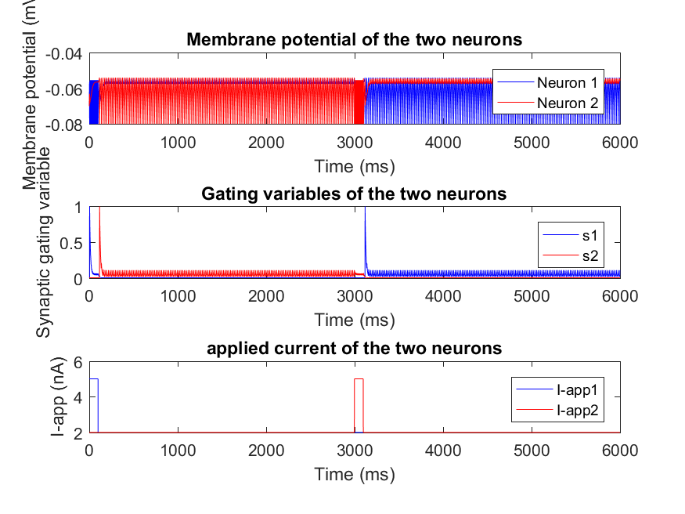

**As the problem did not give me time interval information, I decide to consider it as a 1ms**. During first 100ms, the current injection (3 nA) successfully depolarizes the neuron 1, causing it to fire and rest several times. The synaptic gating variable reaching 1 and quickly decaying to 0 indicates that the neuron fired an action potential, leading to a brief opening of the synaptic channel followed by its rapid closure. I also can see that due to the coupling effect when neuron 1 fires during the first 100 ms, it sends an excitatory signal to neuron 2 and increases its membrane potential in add up steps. After 100ms the applied current of neuron 1 decreases to 2nA but now neuron 2 reaches to the firing threshold and starts firing with specific frequency due to the delayed effects of the first neuron's firing and its ganting variable show brief transient opening and closing (**Excitatory coupling)**. At 3 second mark the applied current causes firing in membrane and full closure of gating variable of neuron 2.. After 3.1 second the applied current from second neuron exited the neuron 1 and its ganting variable become 1 and decays zero ( **Inhibitory coupling)** and starts firing in specific rate and keep the membrane potential of neuron 2 near to its threshold. Overally graphs shows strong inhibition that only one neuron can fire and as it fires it suppresses any activity in the

other neuron.

A3.

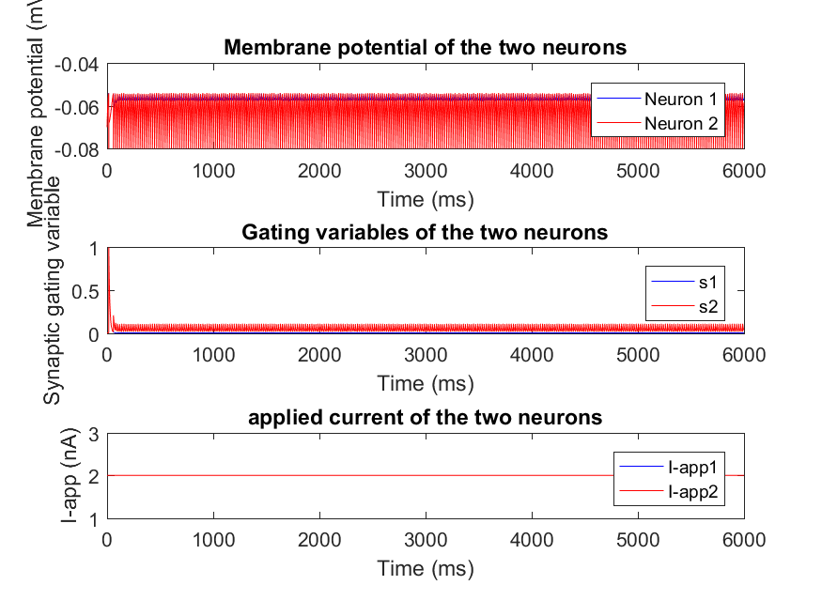

Due to the introduced noise and same applied current both neurons exhibit mutual inhibition and the membrane of both oscillating lower than firing threshold. The overall activity of the gating variables is lower compared to the scenario with applied current, as there's significant presynaptic firing and random switches in the active neuron arise.

A4.

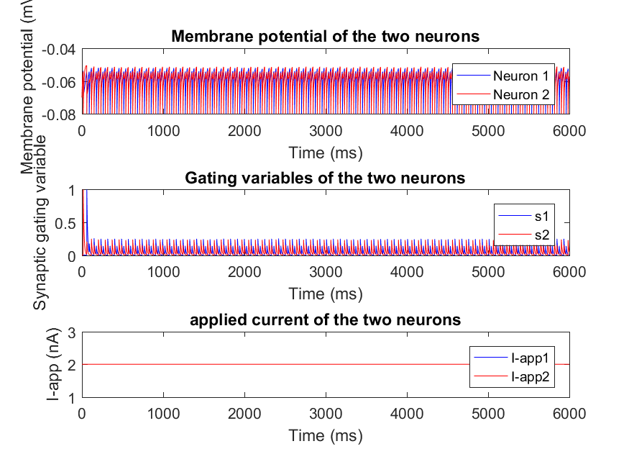

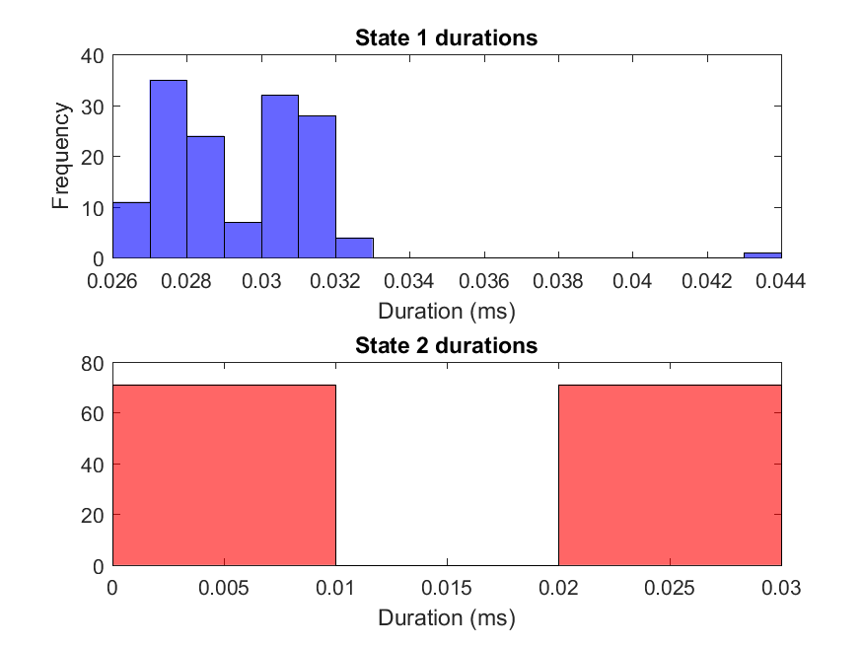

B1.

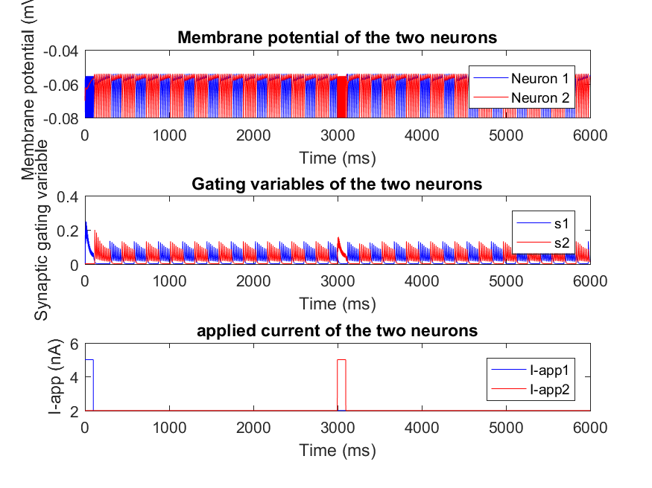

My observation indicates symmetrical inhibitory coupling, where each neuron inhibits the other with equal strength. With no noise and perfectly identical initial conditions, this can lead to a reciprocal inhibition loop that neuron1 fires, triggering an inhibitory postsynaptic potential in neuron 2 that prevents it from firing until its influence decays. When the inhibitory postsynaptic in neuron 2 fades, neuron 1's state can no longer inhibit it, allowing it to fire in turn. The cycle then repeats, leading to both neurons firing one after the other with the same frequency.

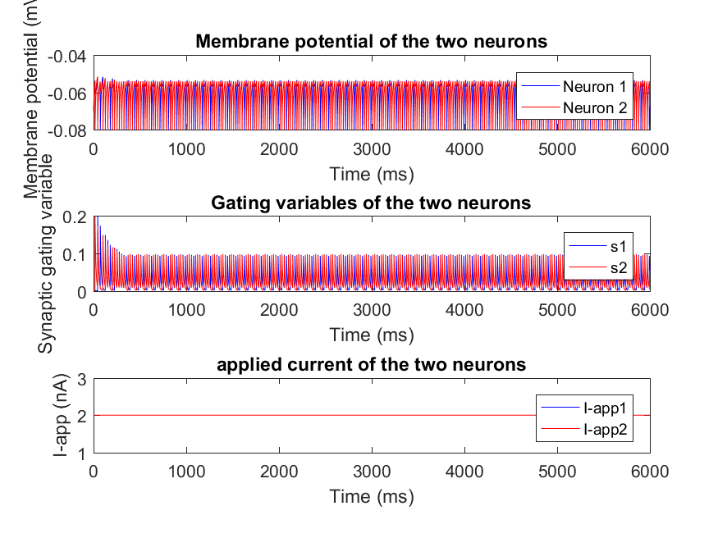

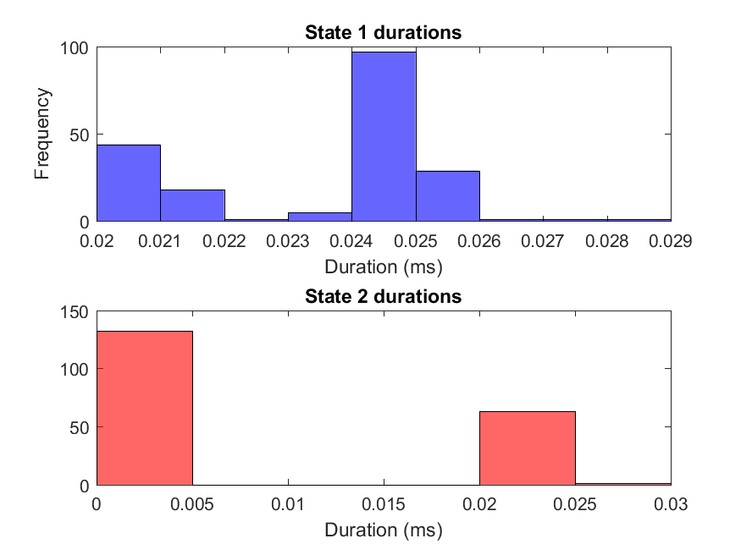

I can see with decreasing variance of noise (noise energy) the random switches in the active neuron decreases. I also can see that the membrane potential of neurons are higher.